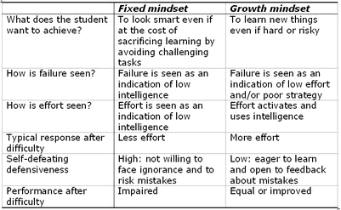
Growth Mindset Praise
At Parochial we encourage pupils to develop a growth mindset. This means we help them to understand that intelligence and skills are not set – or ‘fixed’, but can be improved and grown with effort and determination.
It has been discovered that the way we praise children can have an enormous impact on the way they view their ability. If we praise children for their ability or talent (which is known as ‘trait’ praise) the child will be afraid to fail or show weakness in their skill. This will lead them to only feel good about themselves when they get everything right, so they often choose easier tasks in order to demonstrate their success or, as they see it, how clever they are. However, if we praise children’s effort in their task (known as ‘process’ praise), children will be more willing to have a go at difficult things and make mistakes, as in doing so they do not risk losing your approval, but in fact will gain it for their effort, their resilience and their courage.
Using process praise is a very tricky skill to master! No doubt as children we were praised for our cleverness instead of our mistakes. It is easy to therefore believe that, since we turned out ok, it can’t be all bad. But think back – did you enjoy getting a page of nice neat ticks at school? How did you feel the first time you failed or did not shine at something? Do you or did you ever find yourself choosing an easier challenge so that you knew you would succeed rather than take a risk? These are the actions and emotions of a ‘fixed mindset’, which we in, all probability, developed through our parents and teachers telling us how clever and successful we were!
The result is worth the effort, as developing a growth mindset sets children up for challenges: it prepares them to see mistakes and failure as a learning opportunity and teaches them to bounce back. They develop a more positive attitude to their peers as they become less guarded about their intelligence and more willing to share ideas and challenges. Already, we have seen very positive results in our children, both in those who were traditionally clever and those who struggled, as it gave freedom to take risks to the former and motivation to the latter.
Below are some ideas for the ways that you can praise children to help them develop a growth mindset.
Trait praise (do less of this) | Process praise (encourages growth mindset)
Great job – you must be really clever! | Well done – you kept working at that!
See, you did well – you must be good at this. | You did really well because you listened / practised and it worked!
I told you that would be easy because you’re good at that | You got that quicker this time because you have practised and improved.
It doesn’t matter if you didn’t get it, you’re clever at other things. | What matters is you kept trying and learning from your mistakes.
You are brilliant at football. | You listened to your coach and made the changes and look at the difference it made!
You are a natural at this! | You are getting better because you really try in your practices.

To see the video, Google “Carol Dweck: the effect of praise on mindset”. You will find a link to the Youtube video.
